The Leetcode file system keeps a log each time some user performs a *change folder* operation.

The operations are described below:

* "../" : Move to the parent folder of the current folder. (If you are already in the main folder, **remain in the same folder**).
* "./" : Remain in the same folder.
* "x/" : Move to the child folder named x (This folder is **guaranteed to always exist**).

You are given a list of strings logs where logs[i] is the operation performed by the user at the ith step.

The file system starts in the main folder, then the operations in logs are performed.

Return *the minimum number of operations needed to go back to the main folder after the change folder operations.*

**Example 1:**

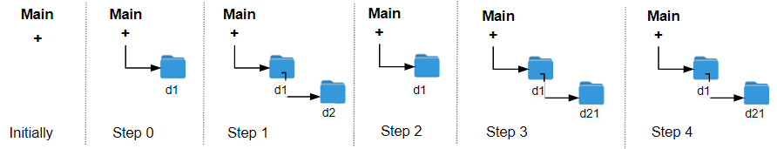

Input: logs = ["d1/","d2/","../","d21/","./"]  
Output: 2  
Explanation: Use this change folder operation "../" 2 times and go back to the main folder.

**Example 2:**

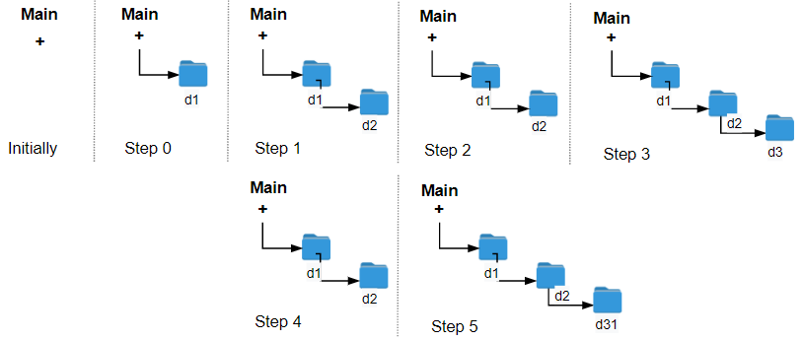

Input: logs = ["d1/","d2/","./","d3/","../","d31/"]  
Output: 3

**Example 3:**

Input: logs = ["d1/","../","../","../"]  
Output: 0

**Constraints:**

* 1 <= logs.length <= 103
* 2 <= logs[i].length <= 10
* logs[i] contains lowercase English letters, digits, '.', and '/'.
* logs[i] follows the format described in the statement.
* Folder names consist of lowercase English letters and digits.